ShopKart E-Commerce Business Analytics
From Database Design to Strategic Business Intelligence

Submitted by: Chetan Prajapat
File: ACE_Project_ChetanPrajapat
Course: BCA 4th Sem BCA
College: Sage university indore
Enrolment no: 24COA2BCA0044

GitHub: https://github.com/grchetan/ACE_Project_Query_ChetanPrajapat/

1. Introduction — Meet ShopKart
ShopKart is an online marketplace operating across major Indian cities, selling products across three core categories. This case study demonstrates a complete SQL Data Analyst workflow — from database design and data insertion to multi-level business intelligence queries.

1.1 Product Categories
Category | Products | Price Range
Electronics | Laptops, Mobiles, Headphones | High-value tech products
Fashion | T-Shirts, Jeans | High volume, lower price-point
Home Appliances | Microwave, Refrigerator, Air Conditioner | Large-ticket, strong margins

1.2 The Management Problem
Despite growing order volumes, ShopKart's leadership faces five critical gaps that require data-driven answers:
- Profit Clarity — Sales are increasing, but profitability remains unclear. Management cannot distinguish high-revenue products from high-profit ones.
- City-Level Anomalies — Certain cities show high order counts but surprisingly low revenue.
- Top Customer Identification — The business needs to identify its most valuable customers for targeted retention strategies.
- Category Performance — No clear view of which product categories are driving profit versus just volume.
- Monthly Growth Tracking — A structured monthly order trend report is needed to understand growth trajectory.

2. Step 1 — Create the Database
The first step is to initialize the ShopKart database environment in MySQL. All subsequent tables and data will live within this database.

CREATE DATABASE shopkart_db;
USE shopkart_db;

This establishes the working schema. The USE statement ensures all subsequent DDL and DML commands are executed within the correct database context — a critical step before any table creation or data insertion.

3. Step 2 — Database Schema Design
ShopKart's relational database is built on five interconnected tables. Each table has a clearly defined primary key, and foreign keys enforce referential integrity across the schema.

3.1 Schema Overview
Table | Primary Key | Foreign Key(s) | Purpose
customers | customer_id | — | Customer profiles and demographics
categories | category_id | — | Product category hierarchy
products | product_id | category_id → categories | Product catalog with price and cost
orders | order_id | customer_id → customers | Order header with status and city
order_items | order_item_id | order_id → orders, product_id → products | Line items linking orders and products

The schema follows a classic star-like structure: Orders sits at the center, linked to Customers (who placed the order), Order Items (what was ordered), and Products (which belong to Categories). This design enables powerful multi-table JOIN queries for business analysis.

3.2 Table Creation — DDL

Customers Table
CREATE TABLE customers (
customer_id INT PRIMARY KEY,
customer_name VARCHAR(100),
gender VARCHAR(10),
city VARCHAR(50),
signup_date DATE
);

Categories Table
CREATE TABLE categories (
category_id INT PRIMARY KEY,
category_name VARCHAR(50)
);

Products Table
CREATE TABLE products (
product_id INT PRIMARY KEY,
product_name VARCHAR(100),
category_id INT,
price DECIMAL(10,2),
cost DECIMAL(10,2),
FOREIGN KEY (category_id) REFERENCES categories(category_id)
);

Orders Table
CREATE TABLE orders (
order_id INT PRIMARY KEY,
customer_id INT,
order_date DATE,
city VARCHAR(50),
order_status VARCHAR(20),
FOREIGN KEY (customer_id) REFERENCES customers(customer_id)
);

Order Items Table
CREATE TABLE order_items (
order_item_id INT PRIMARY KEY,
order_id INT,
product_id INT,
quantity INT,
FOREIGN KEY (order_id) REFERENCES orders(order_id),
FOREIGN KEY (product_id) REFERENCES products(product_id)
);

4. Step 3 — Insert Dataset
The following INSERT statements populate all five tables with ShopKart's sample dataset.

4.1 Customers Data
INSERT INTO customers VALUES
(1, 'Rahul Sharma', 'Male', 'Delhi', '2022-01-10'),
(2, 'Priya Mehta', 'Female', 'Mumbai', '2021-05-20'),
(3, 'Amit Patel', 'Male', 'Ahmedabad', '2023-02-14'),
(4, 'Sneha Reddy', 'Female', 'Hyderabad', '2022-11-01'),
(5, 'Karan Verma', 'Male', 'Delhi', '2020-08-18'),
(6, 'Neha Nair', 'Female', 'Chennai', '2021-09-09'),
(7, 'Rohit Gupta', 'Male', 'Pune', '2023-03-12'),
(8, 'Anjali Singh', 'Female', 'Bangalore', '2022-06-25');

Output:
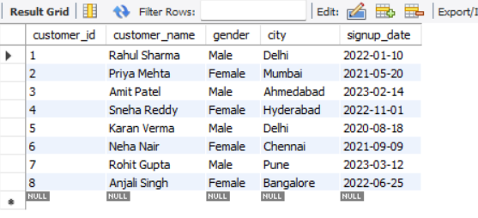

4.2 Categories Data
INSERT INTO categories VALUES
(1, 'Electronics'),
(2, 'Fashion'),
(3, 'Home Appliances');

Output:
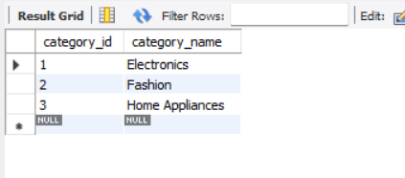

4.3 Products Data
INSERT INTO products VALUES
(101, 'Laptop', 1, 80000, 65000),
(102, 'Mobile', 1, 30000, 22000),
(103, 'Headphones', 1, 2000, 1200),
(104, 'T-Shirt', 2, 800, 300),
(105, 'Jeans', 2, 2000, 900),
(106, 'Microwave', 3, 7000, 5000),
(107, 'Refrigerator', 3, 30000, 24000),
(108, 'Air Conditioner', 3, 45000, 35000);

Output:
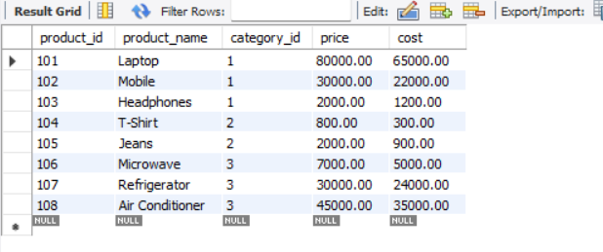

4.4 Orders Data
INSERT INTO orders VALUES
(1001, 1, '2024-01-10', 'Delhi', 'Delivered'),
(1002, 2, '2024-01-11', 'Mumbai', 'Delivered'),
(1003, 3, '2024-01-12', 'Ahmedabad', 'Cancelled'),
(1004, 4, '2024-01-13', 'Hyderabad', 'Delivered'),
(1005, 5, '2024-01-15', 'Delhi', 'Delivered'),
(1006, 6, '2024-01-16', 'Chennai', 'Pending'),
(1007, 1, '2024-02-02', 'Delhi', 'Delivered'),
(1008, 7, '2024-02-05', 'Pune', 'Delivered'),
(1009, 8, '2024-02-08', 'Bangalore', 'Delivered'),
(1010, 2, '2024-02-10', 'Mumbai', 'Cancelled');

Output:
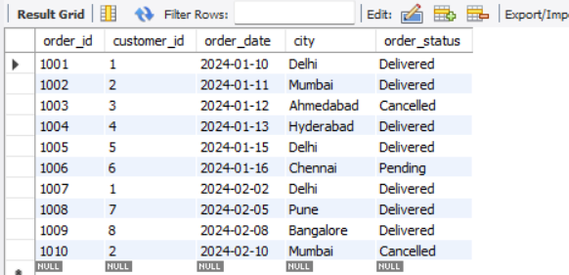

4.5 Order Items Data
INSERT INTO order_items VALUES
(1, 1001, 101, 1), -- Order 1001: Laptop x1
(2, 1001, 103, 2), -- Order 1001: Headphones x2
(3, 1002, 102, 1), -- Order 1002: Mobile x1
(4, 1003, 104, 3), -- Order 1003: T-Shirt x3 (Cancelled)
(5, 1004, 106, 1), -- Order 1004: Microwave x1
(6, 1005, 105, 2), -- Order 1005: Jeans x2
(7, 1005, 104, 1), -- Order 1005: T-Shirt x1
(8, 1006, 102, 1), -- Order 1006: Mobile x1 (Pending)
(9, 1007, 108, 1), -- Order 1007: Air Conditioner x1
(10, 1008, 103, 3), -- Order 1008: Headphones x3
(11, 1009, 107, 1), -- Order 1009: Refrigerator x1
(12, 1010, 104, 2); -- Order 1010: T-Shirt x2 (Cancelled)

Output:
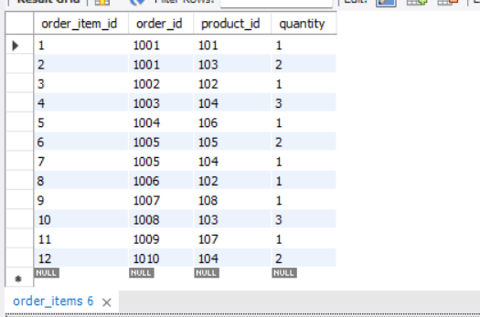

5. Level 1 — Basic Exploration Queries
Level 1 establishes foundational SQL skills — filtering, sorting, and limiting results. These queries form the bedrock of any data investigation.

Q1 — Customers from Delhi
Returns all customers whose city is Delhi. Uses the WHERE clause to filter rows by city value.
SELECT *
FROM customers
WHERE city = 'Delhi';

Result:
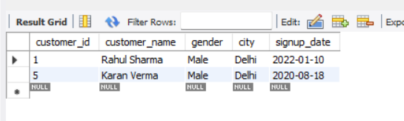

Q2 — Latest 5 Orders
Sorts all orders by order_date in descending order and returns only the 5 most recent. Useful for operational dashboards.
SELECT *
FROM orders
ORDER BY order_date DESC
LIMIT 5;

Result:
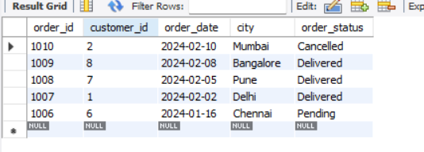

Q3 — Top 3 Most Expensive Products
Returns the three highest-priced items in the catalog using ORDER BY price DESC and LIMIT 3.
SELECT product_name, price
FROM products
ORDER BY price DESC
LIMIT 3;

Result:
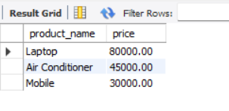

6. Level 2 — Aggregation Queries
Level 2 introduces aggregate functions and grouping — the core of business reporting. These queries answer 'how many' and 'how much' questions at scale.

Q4 — Total Number of Orders
Uses COUNT() to return the total order volume. This is the simplest aggregation and a baseline KPI for any e-commerce business.
SELECT COUNT(*) AS total_orders
FROM orders;

Result:
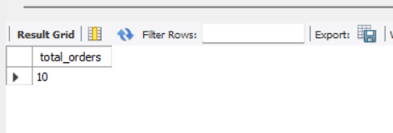

Q5 — Total Quantity Sold Per Product
Groups order line items by product and sums quantities. Reveals which products move the most units — critical for inventory planning.
SELECT product_id,
SUM(quantity) AS total_quantity_sold
FROM order_items
GROUP BY product_id
ORDER BY total_quantity_sold DESC;

Result:
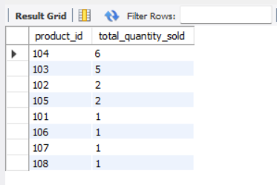
Note: product_id 102 (Mobile) appears in both a delivered (1002) and a pending order (1006).

Q6 — Cities with More Than 2 Orders
Uses HAVING (not WHERE) to filter after aggregation. HAVING is used when filtering on aggregate functions like COUNT().
SELECT city, COUNT(*) AS order_count
FROM orders
GROUP BY city
HAVING COUNT(*) > 2;

Result:
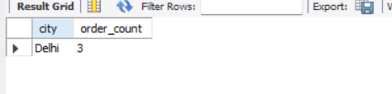

7. Level 3 — Join-Based Real Analysis
Level 3 unlocks the true power of relational databases. By joining multiple tables, we can answer complex business questions that no single table can answer alone.

Q7 — Customer Name with Order ID
Joins customers and orders tables on the shared customer_id key. Produces a human-readable order list with customer names instead of raw IDs.
SELECT c.customer_name, o.order_id, o.order_date, o.city, o.order_status
FROM customers c
JOIN orders o ON c.customer_id = o.customer_id
ORDER BY o.order_date;

Result:
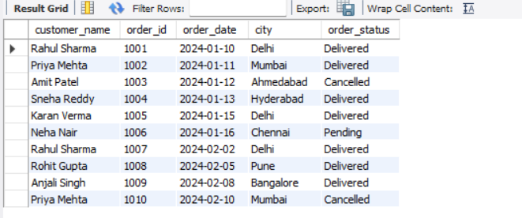

Q8 — Product Name in Each Order
A three-table JOIN spanning orders, order_items, and products. This is the most common pattern in e-commerce analytics — the order receipt view.
SELECT o.order_id, p.product_name, oi.quantity
FROM orders o
JOIN order_items oi ON o.order_id = oi.order_id
JOIN products p ON oi.product_id = p.product_id
ORDER BY o.order_id;

Result:
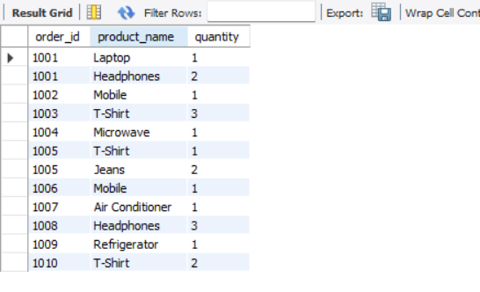

Q9 — Total Quantity Per Customer
Combines JOIN with GROUP BY to aggregate total purchase quantity per customer — a foundation for customer ranking and segmentation.
SELECT c.customer_name, SUM(oi.quantity) AS total_quantity
FROM customers c
JOIN orders o ON c.customer_id = o.customer_id
JOIN order_items oi ON o.order_id = oi.order_id
GROUP BY c.customer_name
ORDER BY total_quantity DESC;

Result:
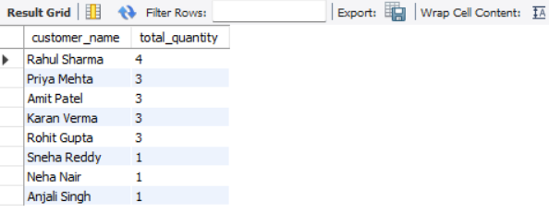

8. Level 4 — Profit Analytics
Profit analytics is one of the most industry-critical SQL skills. The key formula: Profit = (Price - Cost) x Quantity. These queries directly address management's core concern about unclear profitability.

Q10 — Profit Per Product (Per Unit)
Calculates per-unit margin for every product. This reveals that Laptop has the highest absolute margin per unit at Rs. 15,000, while T-Shirt has only Rs. 500 margin per unit.
SELECT product_name, price, cost,
(price - cost) AS profit_per_unit
FROM products
ORDER BY profit_per_unit DESC;

Result:
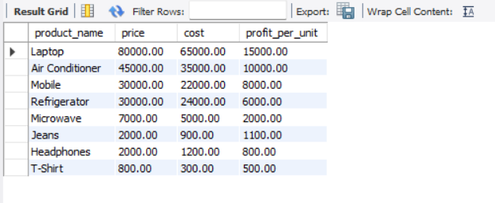

Q11 — Category-Wise Total Profit
A four-table JOIN that rolls up profit to the category level. This answers the management question: which category is most profitable — Electronics, Fashion, or Home Appliances?
SELECT cat.category_name,
SUM((p.price - p.cost) * oi.quantity) AS total_profit
FROM categories cat
JOIN products p ON cat.category_id = p.category_id
JOIN order_items oi ON p.product_id = oi.product_id
JOIN orders o ON oi.order_id = o.order_id
GROUP BY cat.category_name
ORDER BY total_profit DESC;

Result:
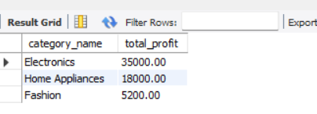

9. Level 5 — Customer Intelligence
Level 5 moves from transactional reporting to customer behavioral analysis — identifying repeat buyers and high-value purchasers using advanced SQL techniques including subqueries.

Q12 — Customers with More Than 1 Order (Repeat Buyers)
Uses HAVING COUNT() after grouping to isolate repeat customers. Repeat customer rate is a key retention KPI for any e-commerce business.
SELECT c.customer_name, COUNT(o.order_id) AS total_orders
FROM customers c
JOIN orders o ON c.customer_id = o.customer_id
GROUP BY c.customer_name
HAVING COUNT(o.order_id) > 1;

Result:
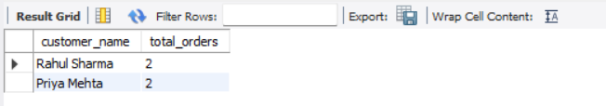

Q13 — Customers Above Average Purchase Quantity
Introduces a subquery to dynamically compute the average purchase quantity and use it as a filter threshold. This is a hallmark of intermediate-to-advanced SQL — the inner query calculates the benchmark, the outer query applies it.
SELECT c.customer_name, SUM(oi.quantity) AS total_quantity
FROM customers c
JOIN orders o ON c.customer_id = o.customer_id
JOIN order_items oi ON o.order_id = oi.order_id
GROUP BY c.customer_name
HAVING SUM(oi.quantity) > (
SELECT AVG(total_qty)
FROM (
SELECT SUM(quantity) AS total_qty
FROM order_items
GROUP BY order_id
) subquery
);

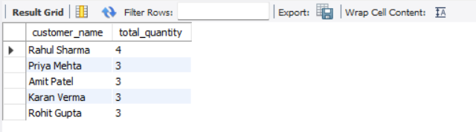
The inner subquery computes order-level quantity averages, and the outer query returns only customers whose total purchase volume exceeds that average — enabling dynamic threshold-based filtering.

10. Level 6 — Strategic Business Questions
Level 6 delivers the executive-level insights that directly inform business strategy — city revenue rankings, product profitability, and growth trends over time.

Q14 — City with Highest Revenue
Addresses the management concern about cities with high orders but low revenue. Multiplies price x quantity per city and ranks them to expose geographic revenue distribution.
SELECT o.city,
SUM(p.price * oi.quantity) AS total_revenue
FROM orders o
JOIN order_items oi ON o.order_id = oi.order_id
JOIN products p ON oi.product_id = p.product_id
GROUP BY o.city
ORDER BY total_revenue DESC;

Result:
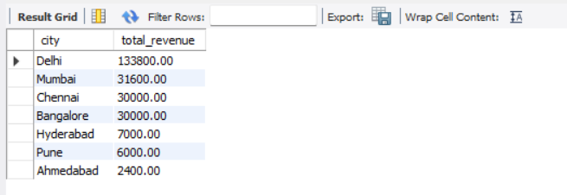

Q15 — Most Profitable Product
Combines margin calculation with quantity sold to find the product generating the most absolute profit — not just the highest price or highest volume.
SELECT p.product_name,
SUM((p.price - p.cost) * oi.quantity) AS total_profit
FROM products p
JOIN order_items oi ON p.product_id = oi.product_id
GROUP BY p.product_name
ORDER BY total_profit DESC
LIMIT 1;

Result:
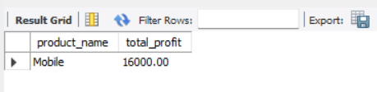

Q16 — Monthly Order Trend (Jan vs Feb 2024)
Uses MONTH() date function to extract the month from each order date and group by it. Produces the monthly growth report management requested.
SELECT MONTH(order_date) AS month_number,
MONTHNAME(order_date) AS month_name,
COUNT(*) AS total_orders
FROM orders
GROUP BY MONTH(order_date), MONTHNAME(order_date)
ORDER BY month_number;

Result:
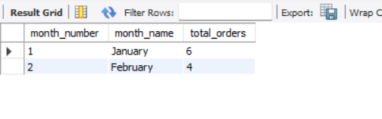
Business Insight: January had 6 orders and February had 4. While February shows lower volume, trend analysis requires more months of data to determine seasonality vs. decline.

11. Final Capstone — Complete Business Intelligence Report
The manager's final requirement: a comprehensive SQL report that consolidates all analytical dimensions into a single business intelligence deliverable.

Capstone Part A — Top 3 Customers by Total Spend
SELECT c.customer_name,
SUM(p.price * oi.quantity) AS total_spend
FROM customers c
JOIN orders o ON c.customer_id = o.customer_id
JOIN order_items oi ON o.order_id = oi.order_id
JOIN products p ON oi.product_id = p.product_id
GROUP BY c.customer_name
ORDER BY total_spend DESC
LIMIT 3;

Expected Result:
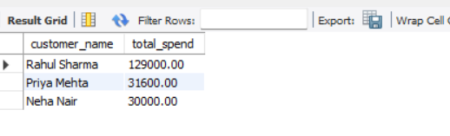

Capstone Part B — Revenue Per City
SELECT o.city,
COUNT(DISTINCT o.order_id) AS total_orders,
SUM(p.price * oi.quantity) AS total_revenue
FROM orders o
JOIN order_items oi ON o.order_id = oi.order_id
JOIN products p ON oi.product_id = p.product_id
GROUP BY o.city
ORDER BY total_revenue DESC;

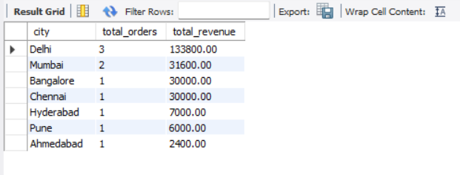

Capstone Part C — Profit Per Category (Full P&L View)
SELECT cat.category_name,
SUM(p.price * oi.quantity) AS total_revenue,
SUM(p.cost * oi.quantity) AS total_cost,
SUM((p.price - p.cost) * oi.quantity) AS total_profit,
ROUND(
SUM((p.price - p.cost) * oi.quantity) * 100.0 /
SUM(p.price * oi.quantity), 2
) AS profit_margin_pct
FROM categories cat
JOIN products p ON cat.category_id = p.category_id
JOIN order_items oi ON p.product_id = oi.product_id
JOIN orders o ON oi.order_id = o.order_id
GROUP BY cat.category_name
ORDER BY total_profit DESC;

Capstone Part D — Repeat Customer Count
SELECT COUNT(*) AS repeat_customer_count
FROM (
SELECT customer_id, COUNT(order_id) AS order_count
FROM orders
GROUP BY customer_id
HAVING COUNT(order_id) > 1
) repeat_customers;

Result:
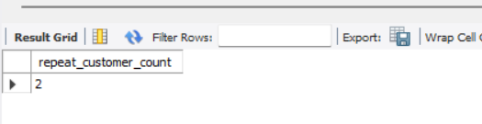

Capstone Part E — Cancelled Order Percentage
SELECT
COUNT(*) AS total_orders,
SUM(CASE WHEN order_status = 'Cancelled' THEN 1 ELSE 0 END) AS cancelled_orders,
ROUND(
SUM(CASE WHEN order_status = 'Cancelled' THEN 1 ELSE 0 END) * 100.0
/ COUNT(*), 2
) AS cancellation_rate_pct
FROM orders;

Result:
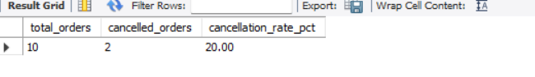

12. Project Summary — Skills Progression
This case study covers the full spectrum of SQL skills required for a professional data analyst role, progressing from basic syntax to strategic business intelligence.

Level | Skills Demonstrated | Queries
Level 1 — Basic Exploration | WHERE, ORDER BY, LIMIT, Filtering | Q1, Q2, Q3
Level 2 — Aggregation | COUNT, SUM, GROUP BY, HAVING | Q4, Q5, Q6
Level 3 — Joins | INNER JOIN, multi-table JOIN patterns | Q7, Q8, Q9
Level 4 — Profit Analytics | Arithmetic expressions, 4-table JOINs | Q10, Q11
Level 5 — Customer Intelligence | Subqueries, nested SELECT, HAVING | Q12, Q13
Level 6 — Strategic BI | MONTH(), date functions, revenue ranking | Q14, Q15, Q16
Capstone — Full Simulation | All of the above combined in P&L reports | 5 Reports

--- End of Assignment ---
Submitted by: Chetan Prajapat
ACE_Project_ChetanPrajapat

